Title | Coordinator Subsystem Software Requirements Specification
Reference | See section 8
Distribution
Author | Lawrence Shi |  | Date | 2015-06-19
Review | See review section |  | Date | See review section
Approved |  |  | Date
Remarks | All Requirements will be implemented as defined in this document and tested accordingly.
Contents

1 Introduction 3
1.1 Scope 3
1.2 Definitions 3
1.3 Acronyms and abbreviations 4
1.4 Document conventions 4
2 Overall description 5
3 Assumptions and dependencies 6
4 Design constraints 6
5 Non-functional requirements 7
5.1 General 7
5.2 Software Verification and Validation 7
5.3 Others 8
6 Functional requirements 8
6.1 General requirements 8
6.2 Subsystems initialization 8
6.3 Tasks management 9
6.4 Software watchdog monitor 10
6.5 Diagnosis information update 11
6.6 FE communication 11
6.7 Time calculate 13
6.8 Password management 13
6.9 Operating mode management 14
6.10 Variable calculation 15
7 Safety Requirements / Error-detection and error-handling 16
8 References 16
9 Revision History 17
10 Requirements review 17

List of Figures
Figure 1 Communication board software architecture 3
Figure 2 Coordinator Subsystem Use Case Diagram 5

List of Tables

Introduction

Scope
This document is intended to specify the software requirements for the coordinator subsystem. The coordinator subsystem is part of the communication board platform shown in figure 1.
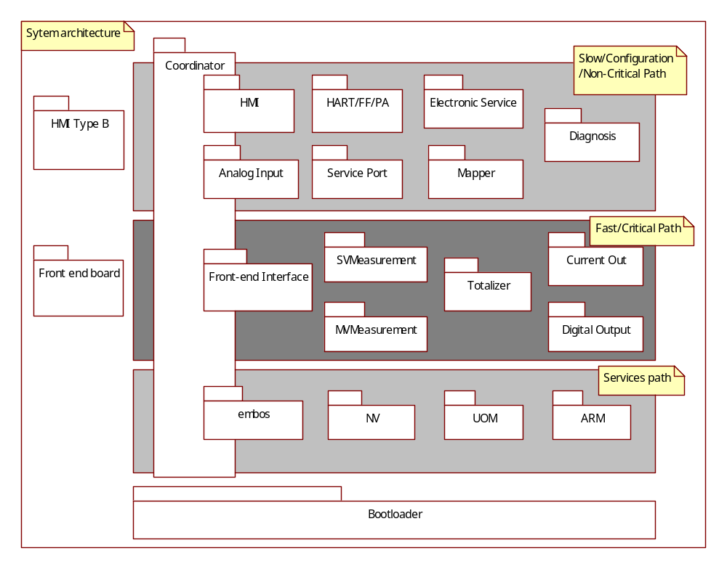
Figure 1 Communication board software architecture
The Coordinator subsystem implements initialize all subsystem, schedules tasks and calculating CPU load and working time.

Definitions

EmbOS | An embedded operating system for the development of real time application for a variety of microcontrollers.
EEPROM | Electrically Erasable Programmable Read-Only Memory.
ServicePort subsystem | VT5 subsystem for providing communications like HMI & HART for service engineer base on HMI connectors.
Mapper Subsystem | VT5 subsystem for mapping the device variable to HART dynamic variable
CurrentOut Subsystem | VT5 subsystem for setting current out value to output PV percent value.
FrontEndInterface Subsystem | VT5 subsystem for exchange data with Frontend board.
ElectronicService Subsystem | VT5 subsystem for providing RAM/ROM check, temperature/ push button check.
NV Subsystem | VT5 subsystem responsible for read / write access and maintenance of non-volatile memories (in transmitter and sensor).
Diagnostic Subsystem | VT5 subsystem responsible for handling error conditions and warnings. Also provides General Alarm data for the Digital Output subsystem.
HART Subsystem | VT5 subsystem for interfacing to HART (Highway Addressable Remote Transducer) protocol communications.
HMI Subsystem | VT5 subsystem providing Human Machine Interface for local user access via display and key input.
SVMeasurement | VT5 subsystem providing Single Variable Measurement, such as volume flow.
MVMeasurement | VT5 subsystem providing Multi-Variable Measurement, such as mass flow, energy flow and so on.
Totalizer Subsystem | VT5 subsystem providing calculation of accumulative total, such as volume, mass, energy and so on.
Digital Output subsystem | VT5 subsystem for setting frequency value to output PV percent value,or totalizer value,or alarm value

Acronyms and abbreviations

HMI | Human Machine Interface
HART | Highway Addressable Remote Transducer
NV | Non-volatile memory
UOM | Unit of measurement
ARM | Access right management
SNR | Signal to noise ratio
CB | Communication board
FE | Front end board
CDT | Coordinator subsystem
CO  DO  IO  RTOS  VT5 | Current out subsystem  Digital out subsystem  Input / output  Real time operation system  Vortex flow meter 5

Document conventions
Software requirements are identified using the following in-line table format:
Ident. | Definition / Motivation | Priority | Source
 |  | Stability | Source
Each field is described in the following list:

Ident. a unique identifier for the Requirement
Priority one of: Mandatory / Desirable / Future
Stability one of: Committed (Agreed by approvers) / Not yet agreed / Likely to change

Overall description
The Coordinator subsystem is the system central subsystem which interacts with all other subsystems in the devices. The coordinator sub-system use case diagram shows as figure2.
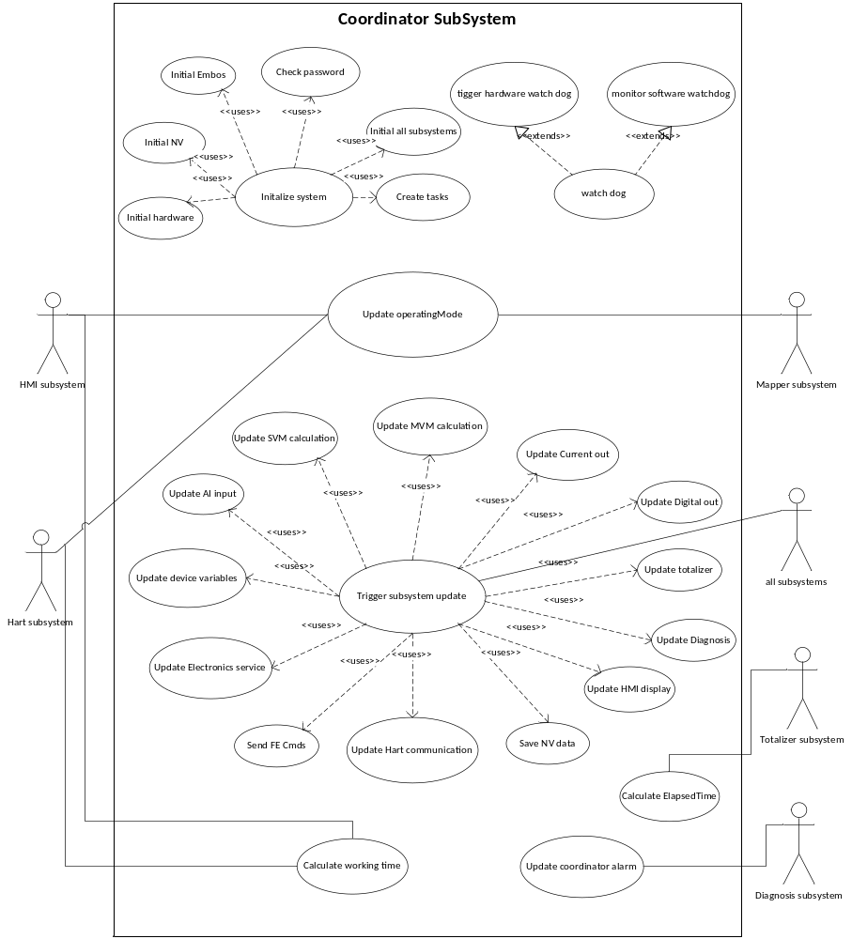
Figure 2 Coordinator Subsystem Use Case Diagram

The main functionalities of coordinator are to be implemented.
- Initializing function:
- Initialize hardware
- Initialize EmbOS
- Initialize NV
- Initialize all subsystems
- Check password of special application
- Create tasks
- Scheduling function:
- Task management
- Subsystem internal function:
- Hardware Watchdog and Software watchdog monitor.
- FE communication.
- Calculate working time.
- Update diagnosis information
- Scheduling process variable calculation
- Password management
- Operating mode management
- Update HMI display

Assumptions and dependencies
All the requirements are derived from VT5 software requirement specification [1] and VT5 F/W design specification [2]
Development and testing will be done based on the following conditions:
- Compiler: IAR Compiler V3. 40
- Framework: 2.3.1

Design constraints

Ident. | Definition / Motivation | Priority  M | Source  [RS004] 3.1.3
CDT_ DC1 | Coordinator Subsystem shall base on ABB framework 2.3.1 [1]. | Stability  C | Source  [RS004] 3.1.3

Ident. | Definition / Motivation | Priority  M | Source  R&D
CDT_ DC2 | Coordinator Subsystem shall use third-party RTOS- EmbOS 3.28 Error: Reference source not found. | Stability  C | Source  R&D

Non-functional requirements

General
Ident. | Definition / Motivation | Priority  M | Source  [RS004] 3.1.1
CDT_NFR1 | The software shall be written in c language or assembly language. | Stability  C | Source  [RS004] 3.1.1

Ident. | Definition / Motivation | Priority  M | Source  [RS004] 3.1.2
CDT_ NFR2 | The system shall be developed on M16C/63. | Stability  C | Source  [RS004] 3.1.2

Ident. | Definition / Motivation | Priority  M | Source  [RS004] 3.1.4
CDT_ NFR3 | Four documents shall be created for calculation subsystem:  - Software requirement specification,  - Software design description,  - Software test plan,  - Software code review. | Stability  C | Source  [RS004] 3.1.4

Software Verification and Validation
Ident. | Definition / Motivation | Priority  M | Source  [RS004] 3.2.1
CDT_ NFR4 | The static code analysis of c code shall be performed with the PC Lint tool and passed with the warning level 3. | Stability  C | Source  [RS004] 3.2.1

Ident. | Definition / Motivation | Priority  M | Source  [RS004] 3.2.2
CDT_NFR5 | - The “Module Test” in this project scope will check the operations and their relations within the system.  - If required, a specific test container environment could be used to simulate the module input signal.  - The Module test will be done by the developer and reviewed with the code review procedure.  - The Module tests shall cover all implemented functions. | Stability  C | Source  [RS004] 3.2.2

Ident. | Definition / Motivation | Priority  M | Source  [RS004] 3.2.3
CDT_NFR6 | For the “Code Review” procedure a second developer shall check the implementation by using the code review questionnaire and his experience about embedded software behaviour.  The code review shall be carried out for the complete subsystem code. | Stability  C | Source  [RS004] 3.2.3

Others
Ident. | Definition / Motivation | Priority  M | Source  [RS004] 3.3.1
CDT_NFR7 | Dynamic memory allocation shall not be used to avoid allocation or deallocation problems. | Stability  C | Source  [RS004] 3.3.1

Ident. | Definition / Motivation | Priority  M | Source  [RS004] 3.3.2
CDT_NFR8 | The system shall provide a method to read and write all the parameters of the device. | Stability  C | Source  [RS004] 3.3.2

Functional requirements

General requirements
Ident. | Definition / Motivation | Priority  M | Source  [RS004] 4.11.1, 4.18.7
CDT_GR1 | The subsystem shall not influence safety critical parameters when it writes non-safety critical parameters during normal operation. | Stability  C | Source  [RS004] 4.11.1, 4.18.7

Subsystems initialization

Ident. | Definition / Motivation | Priority  M | Source  R&D
CDT_INIT1 | If NV error, load rom default value for all subsystem data. | Stability  C | Source  R&D

Ident. | Definition / Motivation | Priority  M | Source  [RS004] 4.18.2
CDT_INIT2 | The system normal start up time shall be less than 10s. | Stability  C | Source  [RS004] 4.18.2

Tasks management
Ident. | Definition / Motivation | Priority  M | Source  [RS004] 4.18.3
CDT_TM1 | The system response time (from vortex signal input to current output/digital output) shall be less than (5τ+5*damping time for current output/digital ouput).  Where,[1τ] is within maximum limits: 3/f or 200 ms, whichever is greater. | Stability  C | Source  [RS004] 4.18.3

Ident. | Definition / Motivation | Priority  M | Source  R&D
CDT_TM2 | The calculation of following subsystems shall be implemented within 150ms:  - SVMeasurement  - MVMeasurement  - Totalizer  - Current output  - Digital output | Stability  C | Source  R&D

Ident. | Definition / Motivation | Priority  M | Source  R&D
CDT_TM3 | The subsystem shall update HMI/service port communication every 150ms. | Stability  C | Source  R&D

Ident. | Definition / Motivation | Priority  M | Source  R&D
CDT_TM4 | The subsystem shall update MaxDN every 600ms. | Stability  C | Source  R&D

Ident. | Definition / Motivation | Priority  M | Source  R&D
CDT_TM5 | The subsystem shall update analog input every 600ms. | Stability  C | Source  R&D

Ident. | Definition / Motivation | Priority  M | Source  R&D
CDT_TM6 | The subsystem shall execute electronic service every 600ms. | Stability  C | Source  R&D

Ident. | Definition / Motivation | Priority  M | Source  R&D
CDT_TM7 | The subsystem shall execute NV data storage every 600ms. | Stability  C | Source  R&D

Ident. | Definition / Motivation | Priority  M | Source  R&D
CDT_TM8 | The subsystem shall execute HART communication every 150ms. | Stability  C | Source  R&D

Ident. | Definition / Motivation | Priority  M | Source  [RS004] 4.11.2
CDT_TM9 | The subsystem shall update diagnosis information within 39 minutes. | Stability  C | Source  [RS004] 4.11.2

Software watchdog monitor
Ident. | Definition / Motivation | Priority  M | Source  [RS004] 4.11.4
CDT_SWDT1 | The subsystem shall monitor all tasks with software watchdogs. | Stability  C | Source  [RS004] 4.11.4

Ident. | Definition / Motivation | Priority  M | Source  R&D
CDT_SWDT2 | All the software watchdogs of each task shall be fed in 10s. | Stability  C | Source  R&D

Diagnosis information update
Ident. | Definition / Motivation | Priority  M | Source  [RS004] 4.11.1
CDT_DI1 | The subsystem shall maintain the diagnosis information of NV subsystem.  - NV error alarm  - Replace FE to CB blocked alarm  - Required FE to CB blocked alarm  - Replace required both direction enable alarm | Stability  C | Source  [RS004] 4.11.1

Ident. | Definition / Motivation | Priority  M | Source  [RS004] 4.11.1
CDT_DI2 | The subsystem shall maintain the diagnosis information of front end board. (Reference [3],Table 8) | Stability  C | Source  [RS004] 4.11.1

Ident. | Definition / Motivation | Priority  M | Source  [RS004] 4.11.1
CDT_DI3 | The subsystem shall detect the following errors state:  - Simulation data alarm  - Alarm simulation alarm  - Maintenance alarm  - Piezo sensor uncalibrated alarm  - Process temperature max alarm  - Process temperature min alarm | Stability  C | Source  [RS004] 4.11.1

FE communication
Ident. | Definition / Motivation | Priority  M | Source  R&D
CDT_FEC1 | The subsystem shall get frequency, temperature, SNR and diagnosis information from FE every 150ms, refer to read command 1 in [3]. | Stability  C | Source  R&D

Ident. | Definition / Motivation | Priority  M | Source  R&D
CDT_FEC2 | The subsystem shall support meter configuration read command, refer to read command 0 in [3]. | Stability  C | Source  R&D

Ident. | Definition / Motivation | Priority  M | Source  R&D
CDT_FEC3 | The subsystem shall read operation hours from FE every 10 minutes, refer to read command 4 in [3]. | Stability  C | Source  R&D

Ident. | Definition / Motivation | Priority  M | Source  R&D
CDT_FEC4 | The subsystem shall read maintenance cycle from FE every 10 minutes, refer to read command 6 in [3]. | Stability  C | Source  R&D

Ident. | Definition / Motivation | Priority  M | Source  R&D
CDT_FEC5 | The subsystem shall support DSP parameters read command, refer to read command 7 in [3]. | Stability  C | Source  R&D

Ident. | Definition / Motivation | Priority  M | Source  R&D
CDT_FEC6 | The subsystem shall support meter configuration write command, refer to write command 0 in [3]. | Stability  C | Source  R&D

Ident. | Definition / Motivation | Priority  M | Source  R&D
CDT_FEC7 | The subsystem shall support FE operation hour reset command, refer to write command 4 in [3]. | Stability  C | Source  R&D

Ident. | Definition / Motivation | Priority  M | Source  R&D
CDT_FEC8 | The subsystem shall support FE maintenance cycle write command, refer to write command 6 in [3]. | Stability  C | Source  R&D

Ident. | Definition / Motivation | Priority  M | Source  R&D
CDT_FEC9 | The subsystem shall support DSP parameters write command, refer to write command 7 in [3]. | Stability  C | Source  R&D
Ident. | Definition / Motivation | Priority  M | Source  R&D
CDT_FEC10 | The subsystem shall support reset DSP parameters to customer default command, refer to write command 8 in [3]. | Stability  C | Source  R&D

Ident. | Definition / Motivation | Priority  M | Source  R&D
CDT_FEC11 | The subsystem shall support reset DSP parameters to factory default command, refer to write command 9 in [3]. | Stability  C | Source  R&D

Ident. | Definition / Motivation | Priority  M | Source  R&D
CDT_FEC12 | The subsystem shall support save DSP parameters as customer default command, refer to write command 10 in [3]. | Stability  C | Source  R&D

Ident. | Definition / Motivation | Priority  M | Source  R&D
CDT_FEC13 | The subsystem shall support save DSP parameters as factory default command, refer to write command 11 in [3]. | Stability  C | Source  R&D

Time calculate
Ident. | Definition / Motivation | Priority  M | Source  [RS004] 4.18.5
CDT_TC1 | The subsystem shall count the CB working hours. | Stability  C | Source  [RS004] 4.18.5

Ident. | Definition / Motivation | Priority  M | Source  [RS004] 4.18.5
CDT_TC2 | The subsystem shall update the CB maintenance cycle every hour. | Stability  C | Source  [RS004] 4.18.5

Ident. | Definition / Motivation | Priority  M | Source  R&D
CDT_TC3 | The subsystem shall provide precise time information for totalizer and digital output. The error of time information shall less than +-0.1%. | Stability  C | Source  R&D

Password management
Ident. | Definition / Motivation | Priority  M | Source  R&D
CDT_PD1 | The subsystem shall maintain three internal unique passwords for the following functions (Reference CDT_INIT4):  - Analog input  - Internal RTD (Temperature sensor on FE)  - Energy operating mode (Liquid power, gas power and steam/hot water power mode) | Stability  C | Source  R&D

Ident. | Definition / Motivation | Priority  M | Source  R&D
CDT_PD2 | The subsystem shall disable the following function if the input password is not matched with internal unique password:  - Analog input  - Internal RTD (Temperature sensor on FE)  - Energy operating mode (Liquid power, gas power and steam power mode) | Stability  C | Source  R&D

Operating mode management
Ident. | Definition / Motivation | Priority  M | Source  [RS004] 4.1.1
CDT_OM1 | The subsystem shall provide 13 operating mode:  - Liquid Volume  - Liquid Normal Volume  - Liquid Mass  - Liquid Power  - Gas Actual Volume  - Gas Standard Volume  - Gas Mass  - Gas Power  - Biogas Actual Volume  - Biogas Standard Volume  - Steam Volume  - Steam/Hot Water Mass  - Steam/Hot Water Power | Stability  C | Source  [RS004] 4.1.1

Ident. | Definition / Motivation | Priority  M | Source  [RS004] 4.1.1
CDT_OM2 | The subsystem shall calling SVM and MVM subsystem to calculate flow related variable according to different operating mode. Refer to table 1 below. | Stability  C | Source  [RS004] 4.1.1

Table 1 operating mode

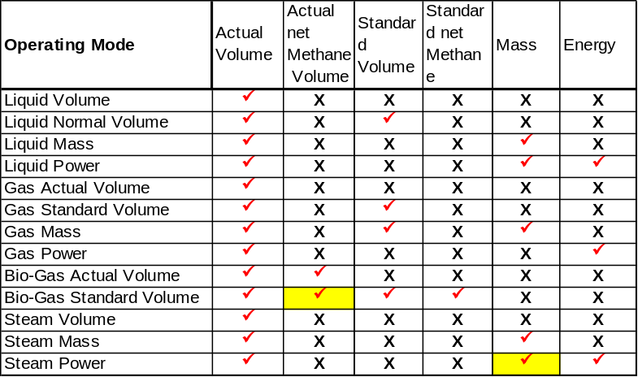

Variable calculation
Ident. | Definition / Motivation | Priority  M | Source  R&D
CDT_VC1 | The subsystem shall calculate the frequency and sensor temperature damping value. | Stability  C | Source  R&D

Ident. | Definition / Motivation | Priority  M | Source  [RS004] 4.17.1
CDT_ VC2 | The subsystem shall simulate piezoelectric sensor frequency from 0.7Hz to 3000Hz. | Stability  C | Source  [RS004] 4.17.1

Ident. | Definition / Motivation | Priority  M | Source  [RS004] 4.17.3
CDT_ VC3 | The subsystem shall simulate pipe temperature from -200°C to 500°C. | Stability  C | Source  [RS004] 4.17.3

Ident. | Definition / Motivation | Priority  M | Source  R&D
CDT_ VC4 | The subsystem shall provide frequency device variable information, including:  - Non damping value  - Damping value  - Classification – 80  - Status  - Damping time | Stability  C | Source  R&D

Ident. | Definition / Motivation | Priority  M | Source  R&D
CDT_ VC5 | The subsystem shall provide temperature device variable information, including:  - Non damping value  - Damping value  - Upper range  - Lower range  - Classification – 64  - Status  - Percentage value  - Damping time | Stability  C | Source  R&D

Ident. | Definition / Motivation | Priority  M | Source  [RS004] 4.3.17
CDT_ VC6 | The damping time (1 Tau) range shall be from 0s to 100s. | Stability  C | Source  [RS004] 4.3.17

Safety Requirements / Error-detection and error-handling

Ident. | Definition / Motivation | Priority  M | Source  R&D
CDT_ SR1 | Coordinator is in the safety loop. | Stability  C | Source  R&D

Ident. | Definition / Motivation | Priority  M | Source  R&D
CDT_ SR2 | Coordinator shall implement SW & HW watch dog.  1. SW watch dog shall supervise deadlocks of tasks.  2. Coordinator shall trigger hardware watchdog every 500ms. | Stability  C | Source  R&D

Ident. | Definition / Motivation | Priority  M | Source  R&D
CDT_ SR3 | Monitor function execution sequence  Coordinator shall implement function execution sequence monitoring for the following loop.  1. The sequence: from signal input, measurement and diagnosis update to signal output shall be monitored.  2. Watchdog task include SW watch dog shall be monitored.  3. Safety Measure execution shall be monitored in case of wrong sequence. | Stability  C | Source  R&D

References
Ref. | Document
[1] | [RS004] VT5 software requirement specification.
[2] | [DS002] VT5 F/W design specification.
[3] | [DS006]VT5 CB and FE Communication Protocols
[4] | ABB BUI Common Framework release 2.3.1

Revision History
Rev. | Description of Version/Changes | Primary Author(s) | Date
0.1 | Initial revision. | Merrick Huang | 2012-09-10
0.2 | Modified according to review comments. | Lawrence Lei Shi | 2013-05-06
0.3 | Correct some typos. | Lawrence Lei Shi | 2013-11-22
0.4 | Chapter6.9 Change to steam/hot water mass, steam/hot water power. CDT_ VC6 damping time range from 0 to 100s | Lawrence Lei Shi | 2015-06-19

Requirements review

Review-Participant:
Dept. | Name
PAMP | Zuochen Wang, Lawrence Shi | 2013-05-03 rev 0.1
PAMP | Zuochen Wang, Lawrence Shi | 2013-05-06 rev 0.2
PAMP | Merrick Huang, Zuochen Wang | 2014-01-08 rev 0.3
PAMP | Merrick Huang, Zuochen Wang | 2015-06-22 rev 0.4

Decision of the Review:
 | Decision | next steps
 | Inspection passed without restrictions | Phase finished
X | Inspection passed with restrictions | Some changes must be done
 | Inspection not passed | Inspection must be repeated

Changes are proved:
The Reviewer confirms that all changes are done:
proved Rev: | Date: | Reviewer:
0.2 | 2013-05-06 | Zuochen Wang
0.3 | 2014-01-08 | Merrick Huang, Zuochen Wang
0.4 | 2015-06-22 | Merrick Huang, Zuochen Wang

Check list:
 |  | yes | no | N.A.
1. | Does the specification explain the currently known requirements that the product finally has to perform? | Y
2. | Are complex subjects explained? | Y
3. | Are all used abbreviations and technical expressions explained? | Y
4. | Are all referenced documents in the reference list? | Y
5. | Contains the document a rough overview of the product’s main functionality? | Y
6. | Are all requirements referenced? | Y
7. | Are all requirements testable? | Y
8. | Is the typical environment of the product described? | Y
9. | Is defined which components already exist, will be bought or self-written? | Y
10. | Are safety requirements (e.g error-detection, error-handling) specified? | Y
11. | Are service/update requirements described? | Y
12. | Are all dependencies to other requirement documents considered? | Y
13. | Are templates used in a correct manner? | Y
14. | Are all open issues transferred to the defects table? | Y

Remarks:
Defects
No. | Checkpoint | Description | Major Defect | done  Date
1 | 3 | Totalizer Subsystem and digital out subsystem are not defined in section 1.2 | N | 2013-05-06
2 |  | Use case “calculate working time” is used by HMI and HART, but use case diagram doesn’t show the relationship. | N | 2013-05-06
3 |  | CDT_INIT1 and CDT_INIT2 are not testable, and should be removed. | N | 2013-05-06
4 |  | CDT_INIT3 is a system requirement, and should be removed. | N | 2013-05-06
5 |  | A new requirement should be added:  If NV error, load rom default value for all subsystem data | Y | 2013-05-06
6 | 6 | Program sequence monitor requirement is not included. | Y | 2013-05-06

